|  |  |  |
| --- | --- | --- |
| **Service Order Form** | **Customer Name** | **: ____________________** |
|  | **Customer Phone** | **: ____________________** |
|  |  |  |

**Progress Motors Imports Limited**

429/432, Tejgaon I/A

Dhaka-1208

Bangladesh

Phone +880 2 8891243

Hotline +880 19 CALL AUDI

www.audi.com.bd



**Audi**

**Service**

|  |  |  |  |  |
| --- | --- | --- | --- | --- |
| **Customer No.** | **Vehicle IdentificationNumber** | **Engine Code** | **Type of Vehicle** | **Kilometer reading** |
|  |  |  |  |  |
| **Vehicle Registration No** | **Received on** | **Due on** | **Service Advisor** | **Service Order No.** |
|  |  |  |  |  |

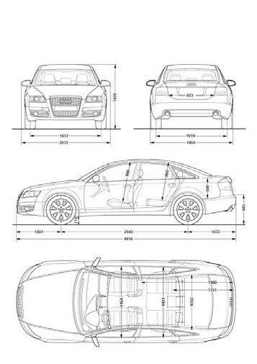

**DAMAGES**

|  |  |
| --- | --- |
| **Item No.** | **Description of Work** |
| **1** |  |
| **2** |  |
| **3** |  |
| **4** |  |
| **5** |  |
| **6** |  |
| **7** |  |
| **8** |  |
| **9** |  |
| **10** |  |

|  |  |  |  |
| --- | --- | --- | --- |
| **Ite m No.** | **Extra Work** | **Authorized** | |
| **Y** | **N** |
| **1** |  |  |  |
| **2** |  |  |  |
| **3** |  |  |  |
| **4** |  |  |  |
| **5** |  |  |  |

|  |  |  |  |  |  |  |  |  |  |
| --- | --- | --- | --- | --- | --- | --- | --- | --- | --- |
| **Recall Campaign** | | **Spare Wheel** | | **Service Book** | | **Tool Kit** | | **Damages** | |
| **Yes** | **No** | **Yes** | **No** | **Yes** | **No** | **Yes** | **No** | **Yes** | **No** |
|  |  |  |  |  |  |  |  |  |  |

**Customer Date/Signature: ___________________________________________________________________________________________________________**

I HEREBY AUTHORIZE THE ABOVE REPAIR WORK TO BE DONE WITH THE NECESSARY MATERIAL, AND HEREBY GRANT YOU AND/OR YOUR EMPLOYEES TO OPERATE THE CAR HEREIN DESCRIBED ON STREET, HIGHWAYS OR ELSE WHERE FOR THE PURPOSE OF TESTINGANDINSPECTION.ANEXPRESSMECHANIC’SLIENISHEREBYACKNOWLEDGED ONABOVECARTOSECURETHEAMOUNTOFTHEREPAIRTHERETO.

CUSTOMERS ARE REQUESTED TO REMOVE ALL PERSONAL BELONGINGS FORM THEIR VEHICLE. SINCE WE DO NOT ACCEPT ANY RESPONSIBILITY FOR LOSS OR DAMAGE TO CARSORARTICLESLEFTINCARSINCASEOFFIRE,THEFTORANYOTHERCAUSEBEYOND OURCONTROL.7DAYSAFTERJOBCOMPLETED,CARMUSTBECOLLECTEDOTHERWISETHE COMPANYWON’TBERESPONSIBLEFORANYDAMAGEORLOSSCAUSED.